**ST.XAVIER’S COLLEGE**

MAITIGHAR, KATHMANDU



**Computer Graphics Assignment #5**

**Draw a Circle using Mid-point Algorithm**

**Submitted By:**

Binod Marikhu

013BSCCSIT013

**Submitted to:**

|  |  |
| --- | --- |
| Er. Anil K. Sah  Lecturer, Department of Computer Science |  |

**Submission on: August 21, 2015**

**STATEMENT**

Draw a circle using mid-point algorithm

**ALGORITHM**

1. Input radius r and circle center (a,b)
2. Assign x=0 and y=r to obtain the first about circle with center at origin
3. Evaluate initial deciding parameter by formula

P = 5/4-r ~ 1-r

1. If(p<0), then increment x by 1 and evaluate p=p+2*x+1

Else goto step 5

1. Evaluate x++ , y-- and p=p+2*x-2*y+1
2. Determine the symmetry points in other seven octants
3. Move each calculated pixel position (x,y) on the circular path centered on (a,b) and plot the coordinate values

x=x+a, y=y+b and

Display->Canvas->Pixels[x][y]=RGB(***,***,***)

1. Repeat steps 4 to 7 until x<=y
2. End

**SOURCE CODE**

//---------------------------------------------------------------------------

#include <vcl\vcl.h>

#pragma hdrstop

#include "Circle.h"

//---------------------------------------------------------------------------

#pragma resource "*.dfm"

TDisplay *Display;

//---------------------------------------------------------------------------

__fastcall TDisplay::TDisplay(TComponent* Owner)

: TForm(Owner)

{

}

//---------------------------------------------------------------------------

void __fastcall TDisplay::DrawCircleClick(TObject *Sender)

{

int r, x, y, a, b;

float p;

r=StrToInt(Edit1->Text);

a=StrToInt(centerX->Text);

b=StrToInt(centerY->Text);

x=0;y=r;

p=1-r;

while (x<=y){

if(p<0){

x++;

p+=2*x+1;

} else {

++x; --y;

p+=2*x-2*y+5;

}

//1st Octane

Display->Canvas->Pixels[x+a][y+b]= RGB(250,000,000);

//2nd Octane

Display->Canvas->Pixels[a+y][b+x] = RGB(000,250,000);

//3rd Octane

Display->Canvas->Pixels[a-x][b+y] = RGB(000,000,250);

//4th Octane

Display->Canvas->Pixels[a-y][b+x] = RGB(200,50,100);

//5th Octane

Display->Canvas->Pixels[a+x][b-y] = RGB(50,200,100);

//6th Octane

Display->Canvas->Pixels[a+y][b-x] = RGB(50,100,200);

//7th Octane

Display->Canvas->Pixels[a-x][b-y] = RGB(025,025,025);

//8th Octane

Display->Canvas->Pixels[a-y][b-x] = RGB(125,125,125);

}

}

//---------------------------------------------------------------------------

**OUTPUT**

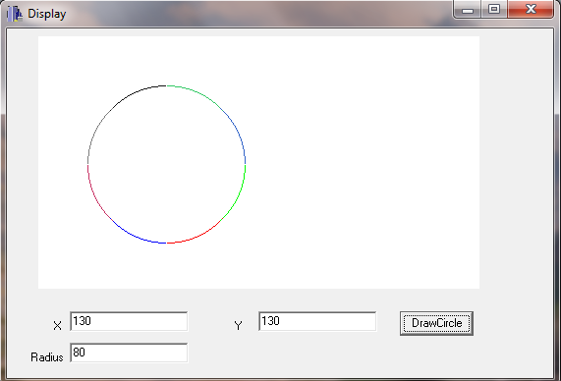

**CONCLUSION**

Hence, a circle of radius 80 units having center at (130,130) was drawn using mid-point algorithm in C++ builder.